Y MOTOR POWER CABLE

- PARTS:

QUANTITY: PART #: NOMENCLATURE: LENGTH:

1 PER MACHINE 19072-1 CABLE, ULTRAFLEX, 18 AWG, 2-CON 80 INCHES

1 PER MACHINE 17025- CONNECTOR, FEMALE, 2 SOCKET N/A

2 PER MACHINE 17023- SOCKET, CONNECTOR N/A

1 PER MACHINE 46160-1 TUBING, SHRINK, ¼” CLEAR 3 INCHES

- ASSEMBLY:

NOTE 1
DO NOT ATTACH THE CABLE CONNECTORS UNTIL THE CABLE HAS BEEN ROUTED THROUGH THE TRACKS AND INSTALLED ON THE MACHINE.

- STRIP 2 INCHES OF THE OUTER INSULATION OF THE CABLE .

- TRIM THE SHIELDING TO THE INSULATION.

- STRIP 2 INCHES OF THE INNER INSULATION OF THE CABLE.

- STRIP 1/8 INCH FROM THE TWO WIRES.

- CRIMP AND TIN CONNECTOR SOCKETS TO THE BARE ENDS, ACCORDING TO DIAGRAM 1.

- INSERT THE SOCKETS INTO THE CONNECTOR ACCORDING TO DIAGRAM 2.



DIAGRAM 1

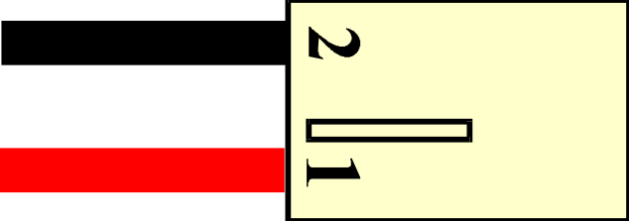

DIAGRAM 2

